MKT 317: final exam questions requiring R or Tableau

Spring 2021; there are 14 questions in this document.

# Instructions

The questions on this document represents a portion of your final exam – the questions in this document are “Part 1” of the final exam. Questions in Part 2 will not be posted before the final exam. You will not need R or Tableau to complete any of the questions in Part 2.

For these Part 1, write your answers on this MS Word document before you begin the final exam.

**When you begin your final exam on D2L, you will enter your answers to these questions into the final exam on D2L. At that time, you will also complete “Part 2,” which are questions that do not require R or Tableau.**

You will not be turning in this MS Word document, so you are encouraged to add screenshots or Tableau and R output, as well as any additional notes you may wish to add.

These are final exam questions. You are **not** allowed to get help from classmates, tutors, the instructor, teaching assistants, individuals on the internet, studying/tutoring websites, or any other source.

You may use your notes and the information on Top Hat.

# Final Exam Part 1

## Tableau questions using data named SS21TableauFinalExamData

Please download the Excel file named **SS21TableauFinalExamData** and import into Tableau.

**Question 1**: What is the sum of sales in **Segment B**? _69,086,305_

**Question 2:** What is the sum of sales for the **North in 2019**? _68,874,286_

**Question 3:** What is the sum of sales for the **North in third quarter of 2019**? _15,132,220_

**Question 4:** Let’s use the data to predict values into the future using year and quarter. We would predict that the sum of sales in the **second quarter of 2021 in the North** is _19,275,806_ .

**Question 5:** Let’s use the data to predict values into the future using year and quarter. We would predict that the sum of sales in the **second quarter of 2021 in the Segment C** is _9,847,510_ .

**Question 6:** Suppose we create a graph where we use the blue pills Year(Date), Quarter(Date), and Month(Date) on the Columns shelf, and SUM(Sales) on the Rows shelf**. What will happen if we add a reference line “by pane”?**

pills in columns shelf are the blue pills year, quarter, and month of date.
The rows shelf contains the green pill for the sum of sales.

(you may wish to include a screenshot of this plot on this document so you can compare the plot with the options on the final exam).

**Question 7:** The plot below represents a line graph “connecting the dots” for the sum of sales for 16 time points: each of the four quarters for each of the four years in the data. Notice that the line graph is one unbroken line.

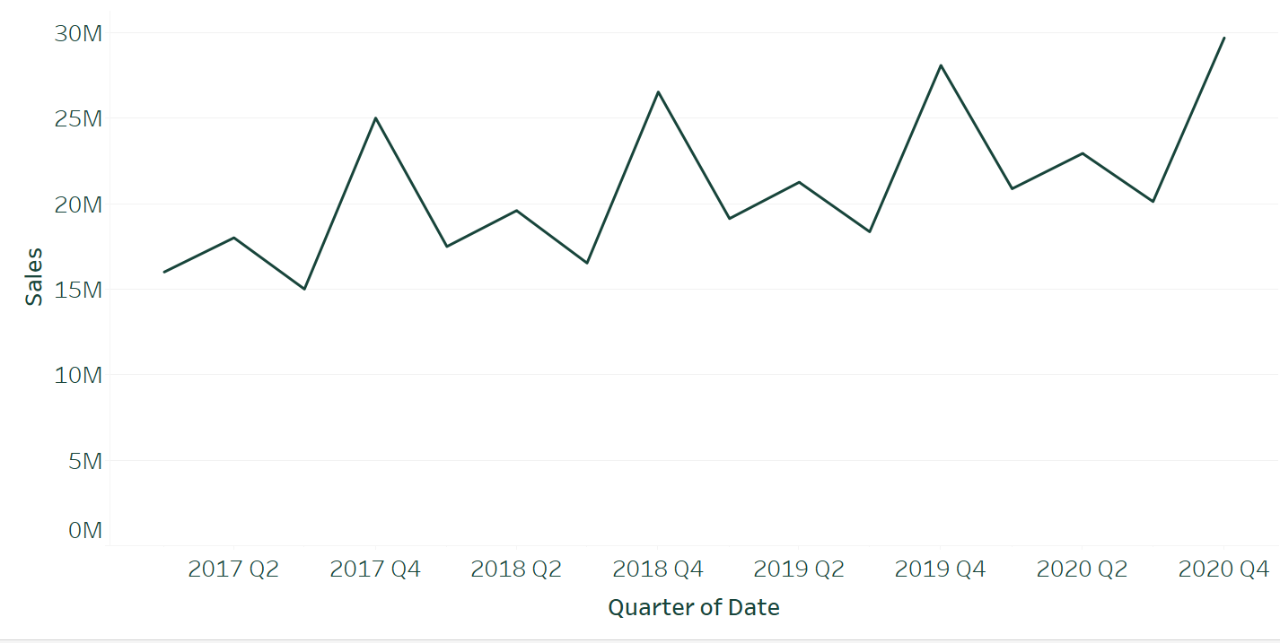

For the image shown above, how is the Date pill formatted in the Columns shelf?

**Options for question 7**

* ~~The Columns Shelf consists of the blue pill QUARTER(Date)~~
* The Columns Shelf consists of the green pill QUARTER(Date)
* ~~The Columns Shelf consists of the green pill YEAR(Date) followed by the green pill QUARTER(Date)~~
* ~~The Columns Shelf consists of the blue pill YEAR(Date) followed by the blue pill QUARTER(Date)~~

## Tableau (or Excel) questions using data named SOSS65

Please load the **SOSS65** data into Tableau (or Excel). This is MSU’s State of the State Survey #65, and is the data we used in the Module 9 Lab.

**Question 8**: In the Module 9 Lab, we computed that a total of 403 people in the data set currently own a dog. Of those 403 individuals, _143_ own a large dog, _68_ own a medium dog, _130_ own a small dog, _58_ own a miniature dog, and the remaining _4_ did not specify the size of their dog. *The size of dogs is included in the “dog size” variable.*

**Question 9**: There are 138 individuals in the data who live in a **small city or town** that currently own a dog.

_44_ of these 138 respondents indicated that they currently own a **large dog (over 50 pounds).** *The “small city or town” information is included in the “community type” variable.*

The answer should be a number of people, not a percentage.

## R questions (you do not need to import a data set)

**Question 10:** Suppose we have counted the number of individuals who purchase a specific new item.

|  |  |
| --- | --- |
|  | **Overall** |
| **Purchase new item** | 400 |
| **Do not purchase new item** | 1800 |

We are 95% confident that the proportion of individuals in the population who will purchase the new item is between _20.33506_% and _24.2294_%.

**Question 11:** Suppose we have counted the number of individuals who purchase a specific new item and separated into segments.

|  |  |  |
| --- | --- | --- |
|  | **Segment A** | **Segment B** |
| **Purchase new item** | 190 | 210 |
| **Do not purchase new item** | 800 | 1000 |

Use R to compute a t-test that compares the difference in population proportions between Segment A and Segment B. The p-value for that t-test equals _0.2912_

**Questions 12-14:** In R, there is a built-in data set named mtcars. We have used this data set several times throughout the course.

Create a multiple linear regression model using the mtcars data set where the

* y-variable is qsec
* the model contains the three x-variables: disp, hp, and cyl.
* Please treat these three x-variables as **quantitative variables** in the model (not categorical).

**Question 12:** What is the coefficient of cyl? -0.565715

**Question 13:** What is the p-value associated with the coefficient of disp? 0.01910

**Question 14:** What is the R-squared for this model? 0.5918

# Final Exam Part 2

Final Exam Part 2 will consist of questions where you will not need R or Tableau. Part 2 of the final exam will be formatted like Exam 1 and 2. These questions will not be posted ahead of time – you will see them when you open the final exam on D2L.

There will be approximately 30 to 35 questions in Part 2.

# Final Exam Info in general

* All questions requiring R or Tableau are included in Part 1, and questions not requiring R or Tableau are in Part 2.
* About half the points for the final exam will be for topics associated with Modules 9 and 10.
* There will be some questions from Modules 9 and 10 that are not included on this document!
* About half the points for the final exam will about big ideas from Modules 1-8. The best way to study these big ideas is to review Exam 1, Exam 2, and the Exam 2 Bonus Points Assignment.